1. Git and Github
2. Clear :- To clear the data
3. Git –version :: to check the version
4. Git –help
5. Git help then cmd you need to get an help for eg (get help init)
6. Git config –global user.name “DC”
7. Git config –global user.email “fargonmer96@gmail.com”
8. Favorite Text Editor
   1. Git config –global core.editor “notepad”
      1. Notepad test.txt
   2. Start notepad++ test1.txt
   3. Git config –global core.editor “Atom”
      1. Atom test2.txt
9. Git config –list (it displays all the username, email, editors which we setuped earlier

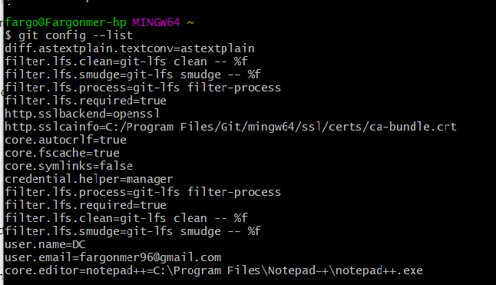

**Basic Commands**

1. I created this on github
2. Mkdir shop (Make a directory)
3. Cd shop (change the directory)
4. Git init (Track this directory which you created ) This will initialize the empty git repository. We can track all the changes which we make from now in this dir.
5. Cd .. to go back cd shop
6. ls -A we can see that git directory



* 1. cd .git
  2. ls -A Number of items git placed in this dir.

1. **Git st** [ it creates the text file]
2. ls
3. git status [ to check the status of the text file which we created]
4. git add list.txt [Tells git to start tracking this particular file] this is called staging
5. we need to commit this file
6. git log [ tells us the history of commits for this file]

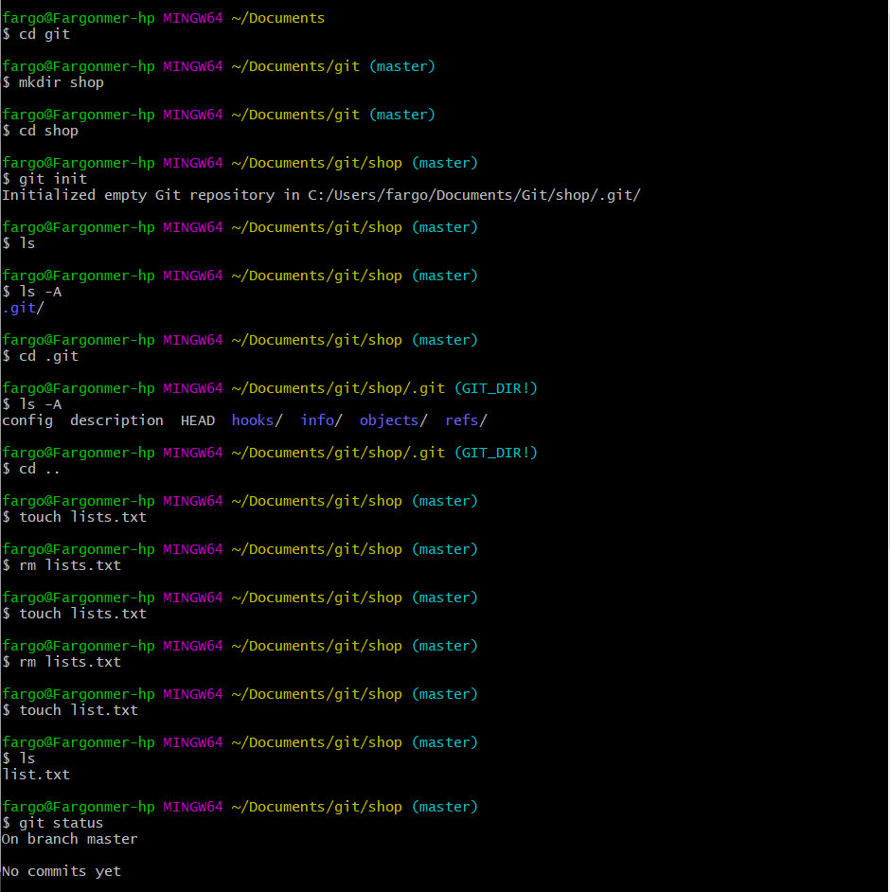

no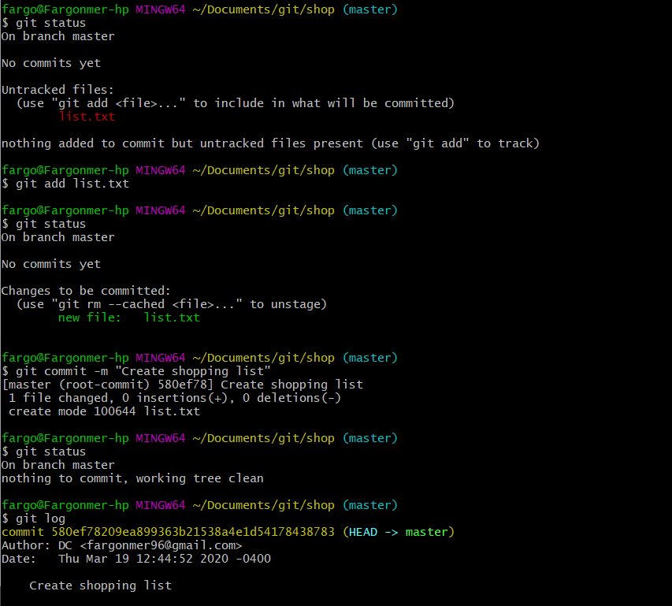

**Exploring Git**

1. We opened the **notepad list.txt** and added some items in my shopping list
2. When I check my **git status** it displays you have modified the file and it’s on master. But it hasn’t been told to save a snapshot of this yet.

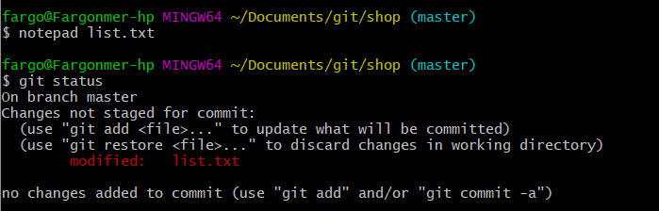

1. **Git diff** will tell the changes that we made in the text file. (Compares the previous and present changes we
2. **Git add list.txt** and **git status**  shows the below .

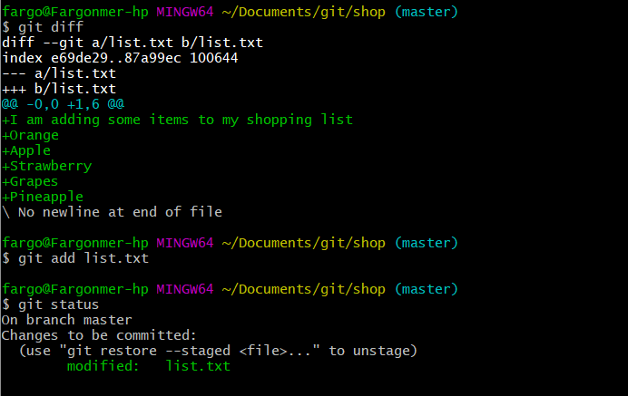

1. We have to commit that file to the master by using

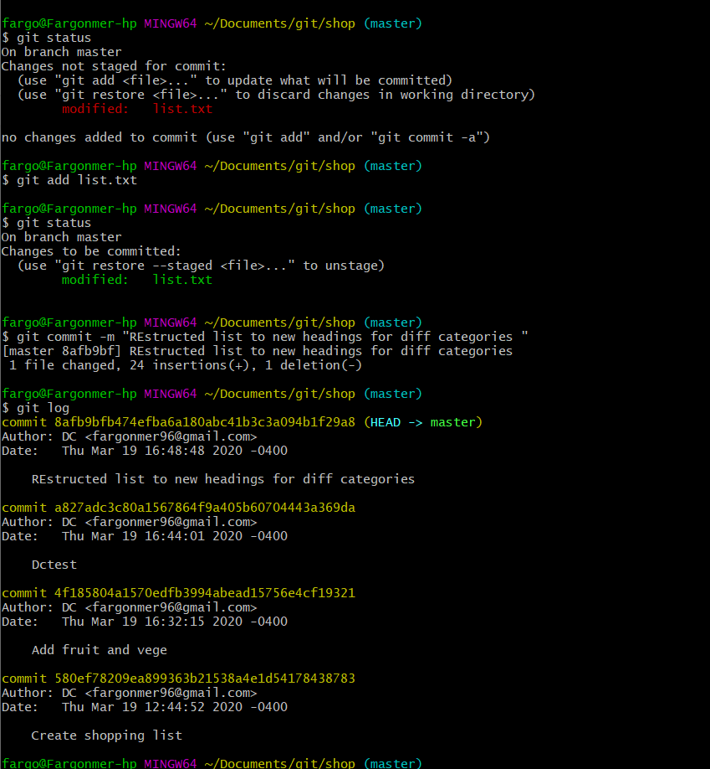

1. **Git log -1**  it will gives us the latest commit

**Git diff**

1. **Git diff – staged**  Before committing if we want to see the diff then we do staging

**Head**

1. **Git diff** and commit code 5 digits **list.txt :**  shows the difference between the two files .

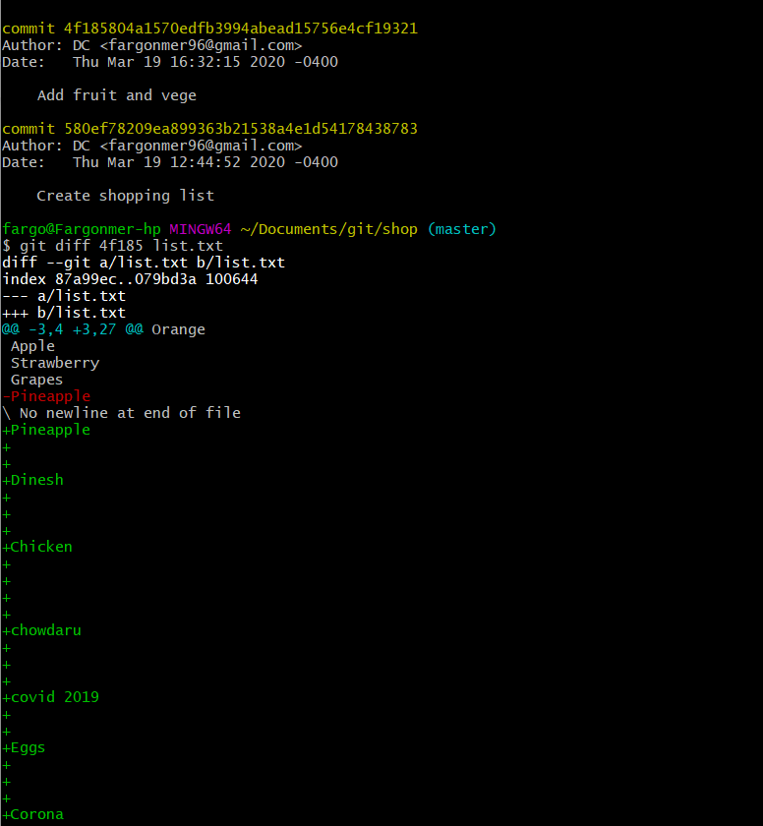

1. **Git checkout head~4 list.txt :** We get the original file(Root file) before we make any changes.

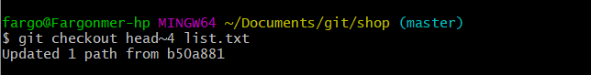

1. This will give the latest version of your shopping list

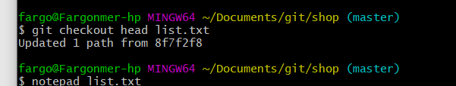

**Making corrections Git reset**

1. **What happens when make mistakes ?**
2. Use this cmd to undo those changes  **git reset list.txt** Git diff –staged
3. Mistake file commit to and we have to reset to previous file then

**Git reset head~1 –soft :-**It removes our mistakes commit files

1. Latest commit has been removed but the **staged** part has been there.
   1. Then we use **git reset head~1 –mixed**
2. **Git reset head~1 –hard”:-**-head is now at previous head and the changes which we make on the file also removed.

**Branching**

1. Create branches **git branch meat(names )**
2. **Git checkout dairy** Switch the branch
3. We are creating different branches by using **git branch name** 
   1. Opening a file and make changes to that file in the branch instead of master
   2. Then merge those branch to the master by using the **git merge branchname**
   3. All those change which you made will be merged to the master file.

**Github**

1. We want to synchronize our local repository with new repository on github
2. **Git help remote**

**Transfer files from from Git to GitHub**

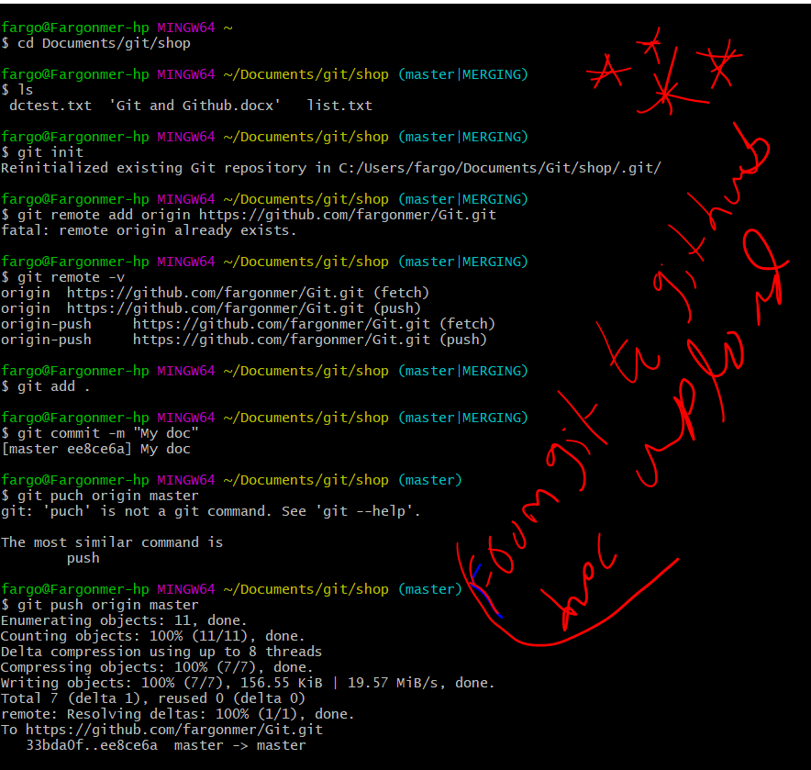

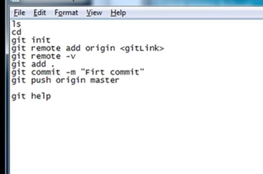

**To force our documents to merge into the master.**

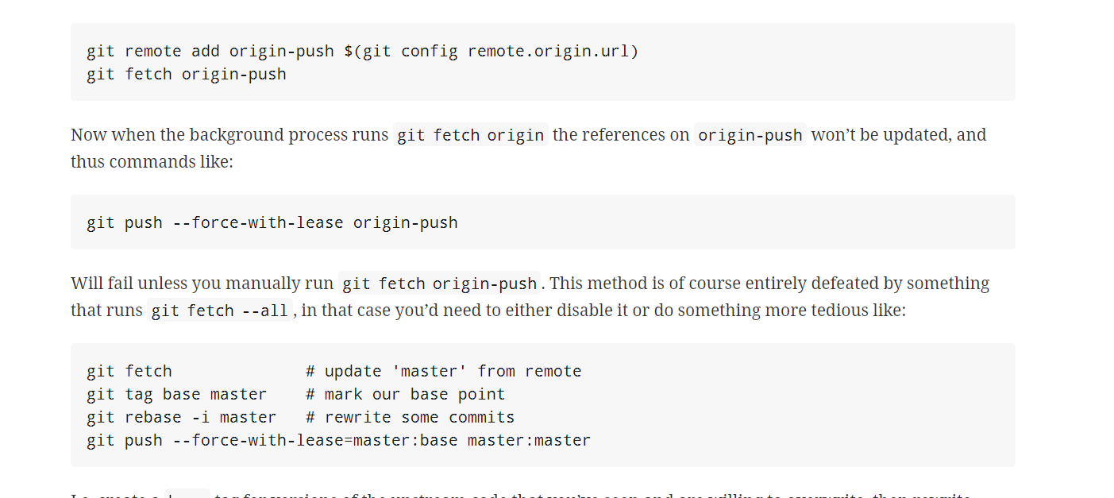

**To clone a Repository from github to your local desk**

**Git fetch and git pull**

1. Create a folder if you like
2. Then copy a https link from gitbhub fro cloning.
3. Then use this command git clone [link]

